Regression

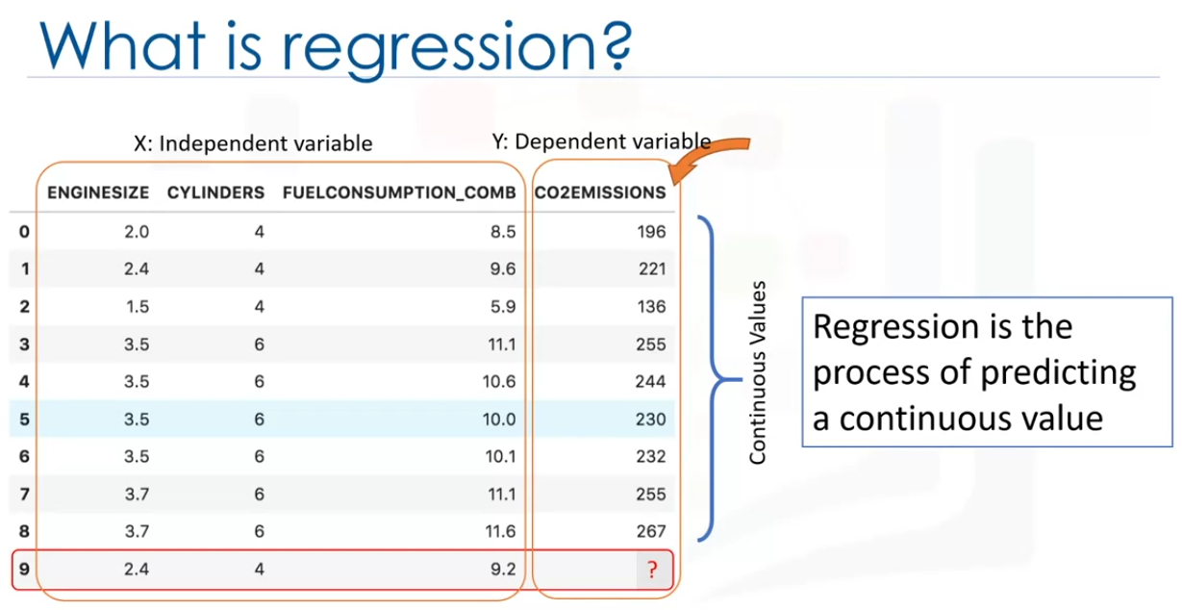

In regression we have independent variables and dependent variables. X and Y.

A regression model relates Y(dependent variable) to X (independent variables).

In other word Y = f(X).

The independent variabe needs to be continuous. not a discrete value. However, the independent variables can be categorical or continuos values.

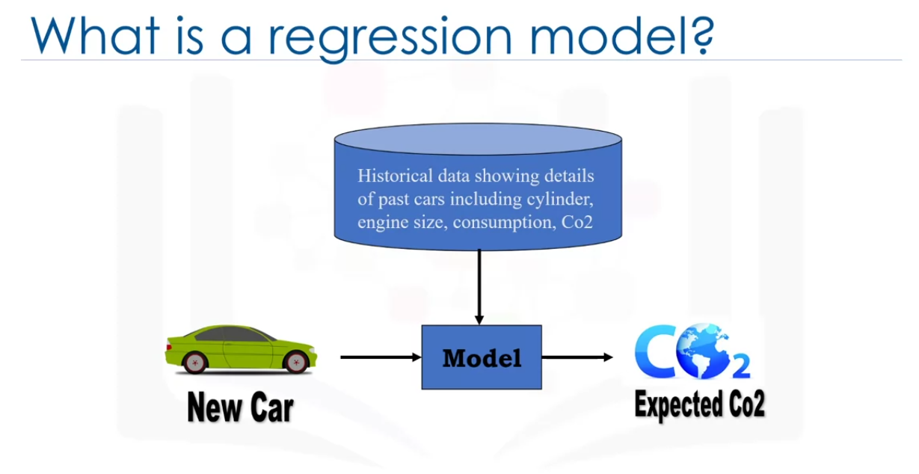

Here we want to use the historical data of the cars with the known CO2 emissions and make a model. Now this model can predict how much Co2 is emitted for an unknown car.

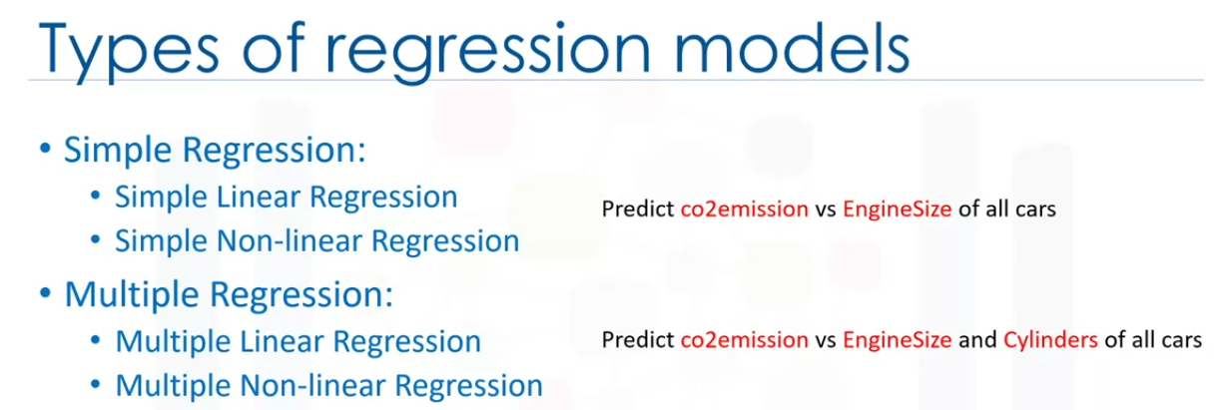

Regression can be linear or non-linear. Linearity of regression depends on nature of relationship between independent and dependent variables.

If we use multiple variables, then its called multiple linear variable.



We can predict total sales of a person based on age,years of experience and education qualification.

It can be used in psychology for example to dertmine individual satisfaction, based on demographic and psycological factors.

We can predict price of a house based on the number of bedroom, bathrooms, squarefoot, distance from main road, amenities etc.

We can prdict employee income using age,years of experience and education qualification.

it can be used in manu fields like finance, healthcare, retail and more,

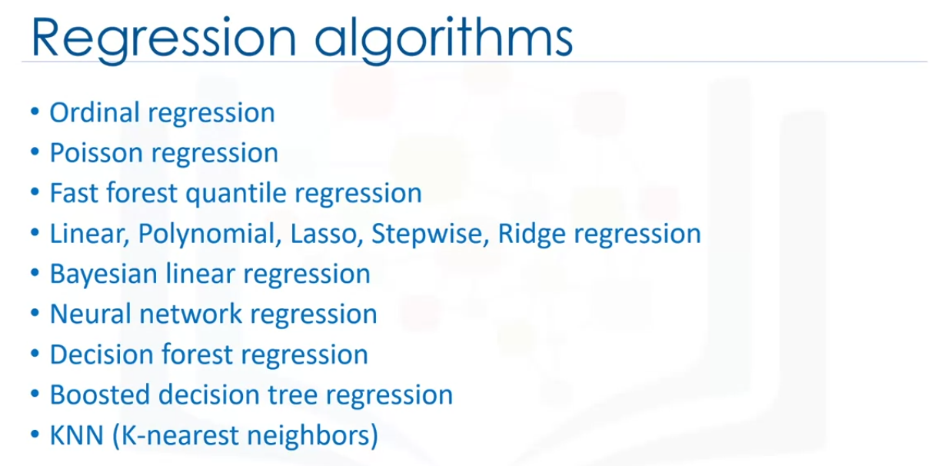

Each of the above algorithms are used for different situations, but the basics are similar.

Simple Linear Regression

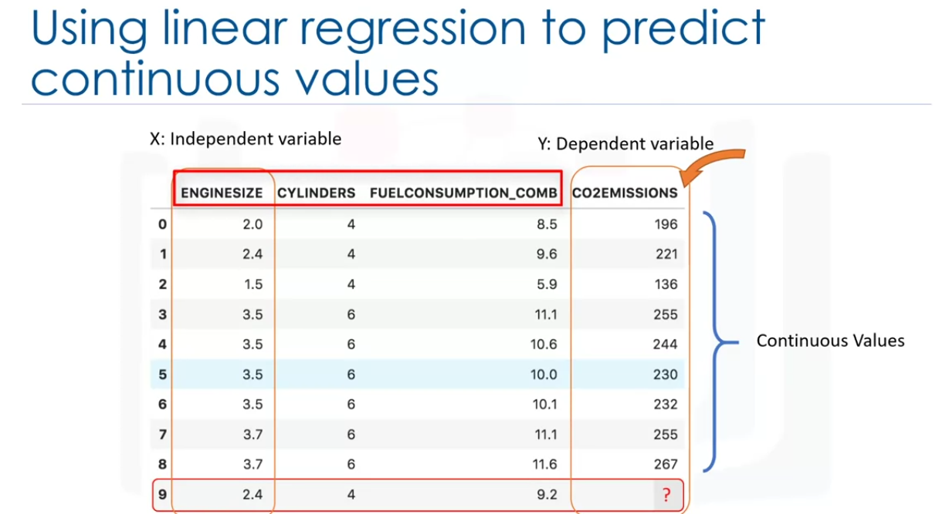

There is only 1 independent varuable. Dependent variable cannot be discrete.

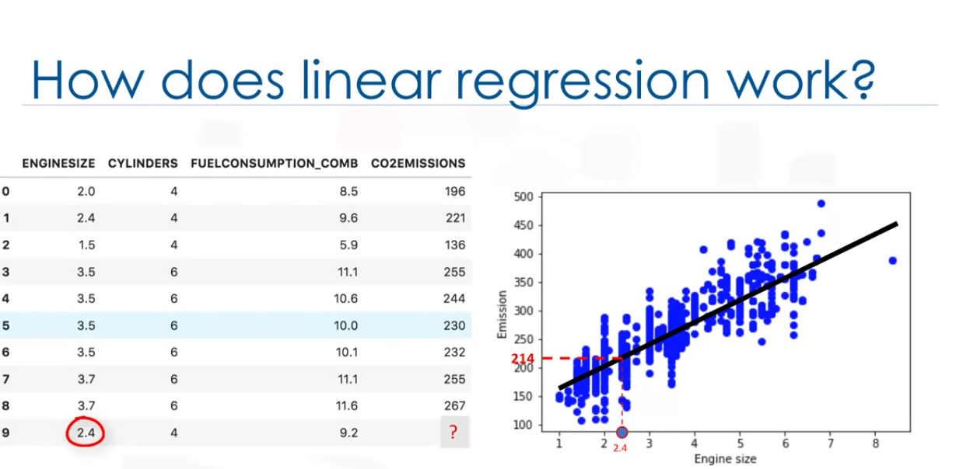

The above scatter plot shows that there s a linear relationship between engine size and co2 emissions and its a postive correlation.

We can fit a regression line and create a good regression model to predict the approximate emission of a car.

we can see if the engine size is 2.4, the grapph show the emission is 214.

lets see what the fitting line is

We are going to predict the target variable by using the dependent variable

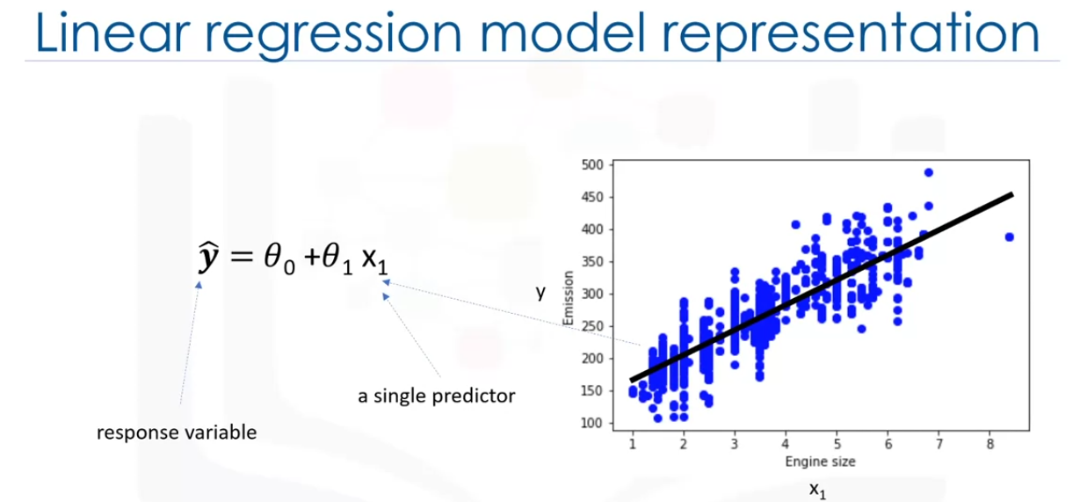

The linear line can be shown traditionally with the formula y = mx + b where m is the slope and b is y intercept(also called as bias). In a simple linear regression there be only 1 x varibe in the formula. a and be are also called coefficients of tje linear equation.

How do we use this to fit a line?

Linear regression gives us estimates of these coefficients to fit the line . This means we need to calculate a and be to find the best fit for the data onto the line. Lets see how we can find the best fit or in other words how to adjust the parameters.

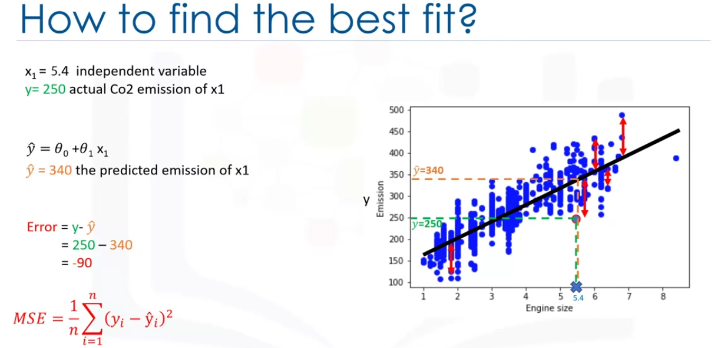

Lets say we have a cat with engine size as 5.4 and actual emissions is 250 based on the data provided. But if we use the fit line in other words using the polynomial with known parameters to calculate predicted value on the line, we get 350. This is very far from 250 which is not good. The error(also called residual error) for this particular data point(difference between predicted value vs the actual value) is 90

We can calculate the mean squared error by finding error of all the data point , performing squares and finding the average of them gives us MSE. The MSE has to be smaller for the line to be best fit.

So picking best possible a and b value can minimize the MSE giving us a best fitted line. Then we can use this line to predict closest approximations for the new cars.

We can also tell if it a good fitbased on the graph. if the points are far from the fit line it might not be the best model.

So how do we select the a and b values? should be random? Also should we always use the minimum MSE value? not really. Somethimes there can be outliers some times linear regression might not be a best fit at all.

We have two options to select a and b values.

1. Mathematical approach.
2. Optimization approach.

lets see how mathematical formula can be used to calculate a an b.

we need to find the mean of inependent(X) and dependent column(Y) from the dataset. xhat and yhat from the following formula are the means.

Then we can use the formulas below to find slope first and then the y intercept

Note this is still and estimation as other factors might contribute for the change in the co2 emissions value.

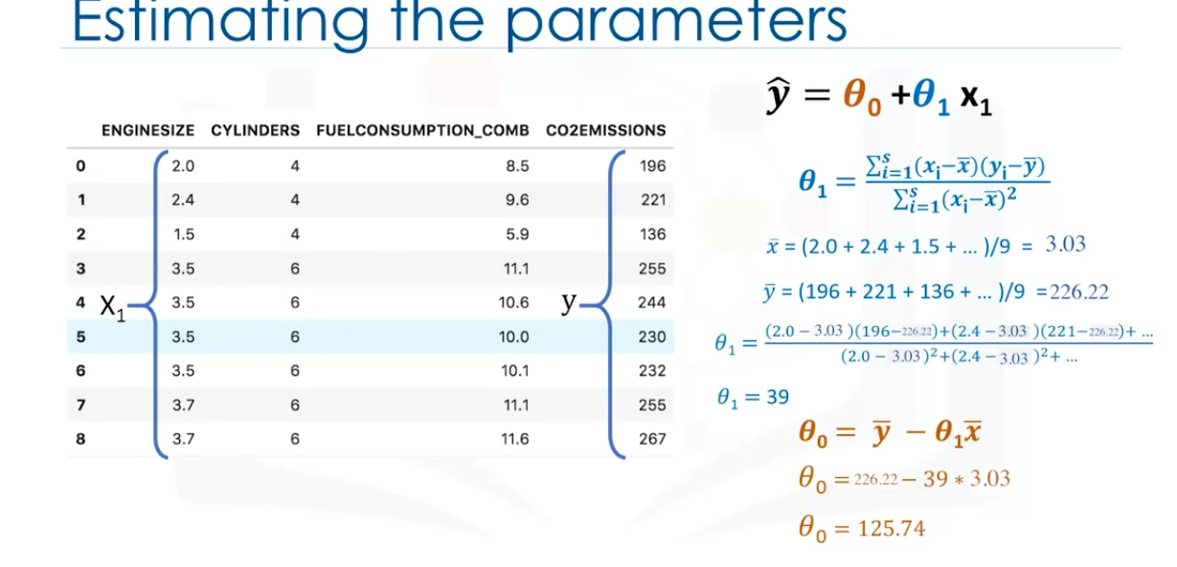

Now we can use the a(slope) and b(y intercept also know as bias) to calculate the approximate value for co2 emissions for the new car with 2.4 as engine size.

so from the values we get the equation as y = 125.74 + 39x where x is the engine size in this case.This gives us 218.6 when we put 2.4 instead of x 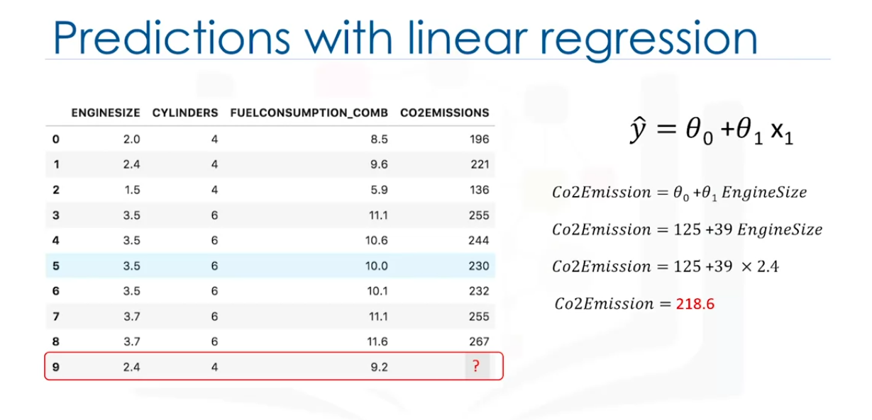

Lets see why Linear regression is useful.

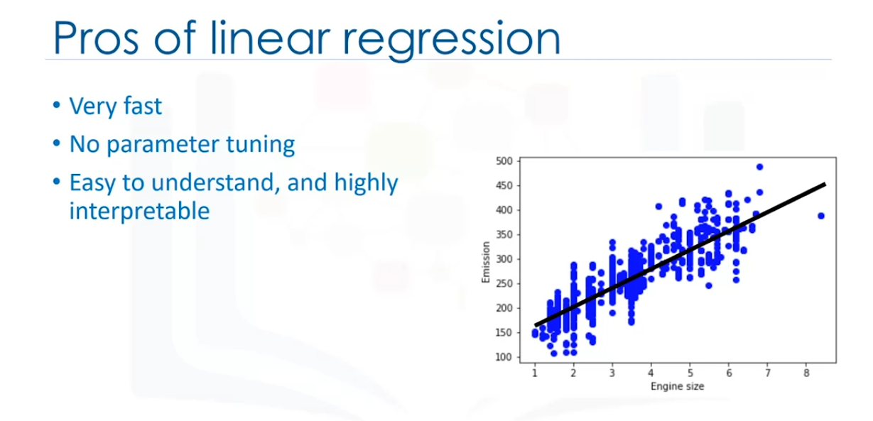

Model Evaluation in Linewar Regression Models

After building the model we need to evaluate the model to check if it a good fit.

Two types of evaluation methods are shown here.

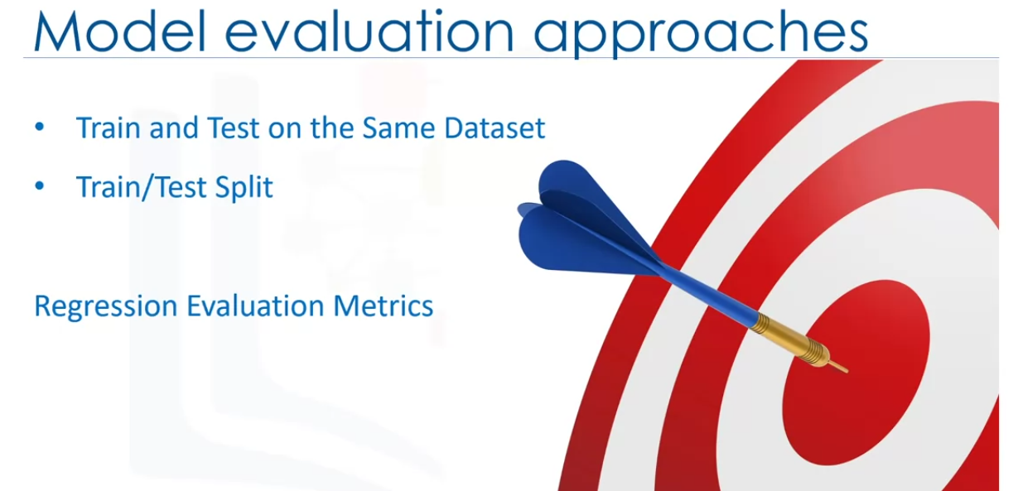

How to calculate accurate model?

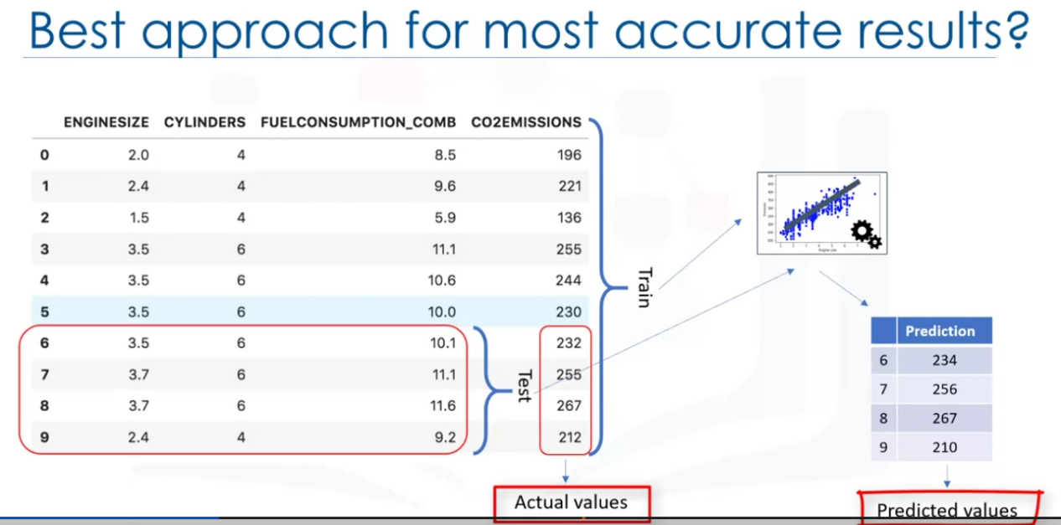

One way we can do this is by selecting portion of the data for testing (without labels) and the remaining can be used for training.

Then we train the model with all the data and predict the co2 emissions for the test data.

Now we compare the estimated vs actual values and find the accuracy of the model. we can use differnt metrics to do this.

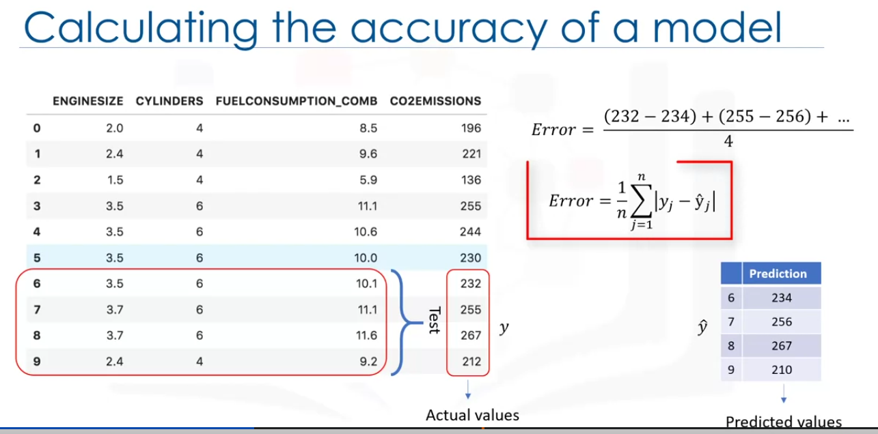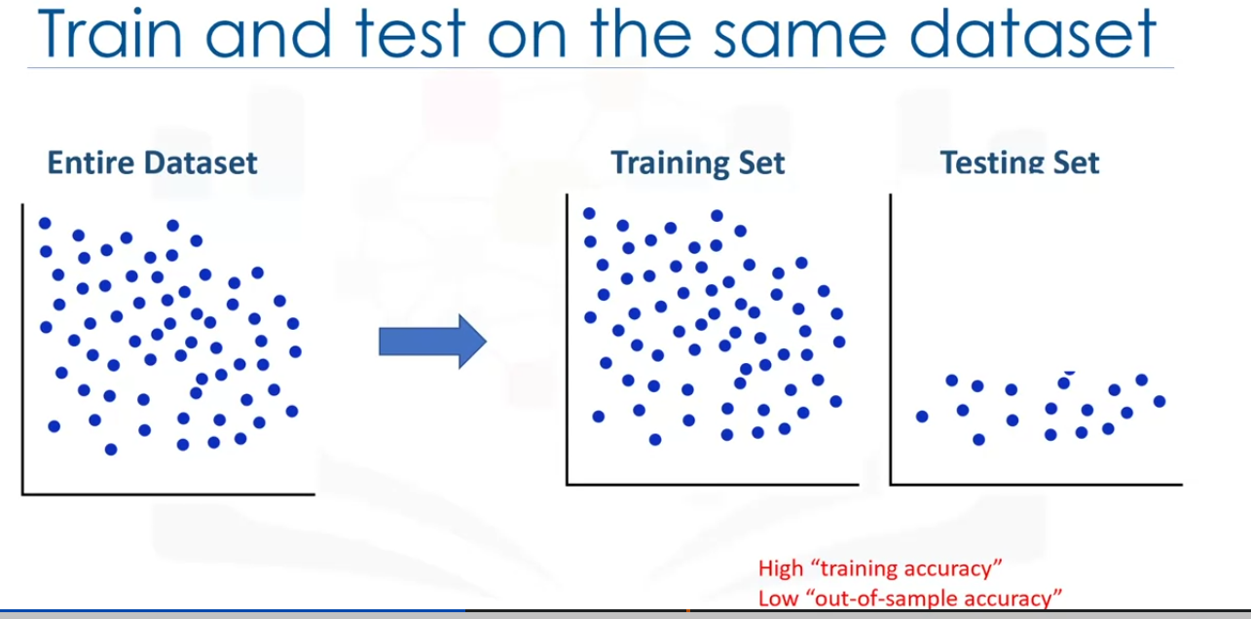

Now this model that we built will have high training accuracy but very low out of sample accuracy.

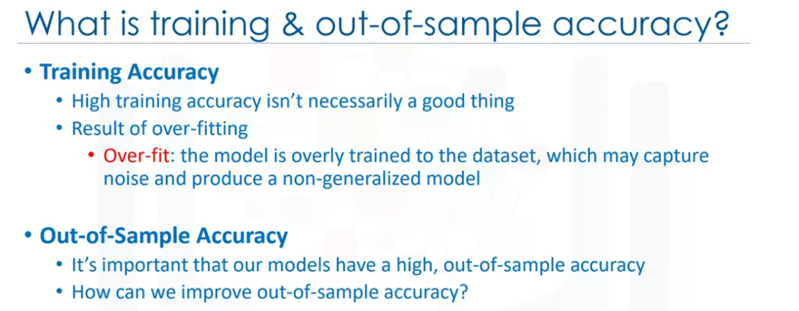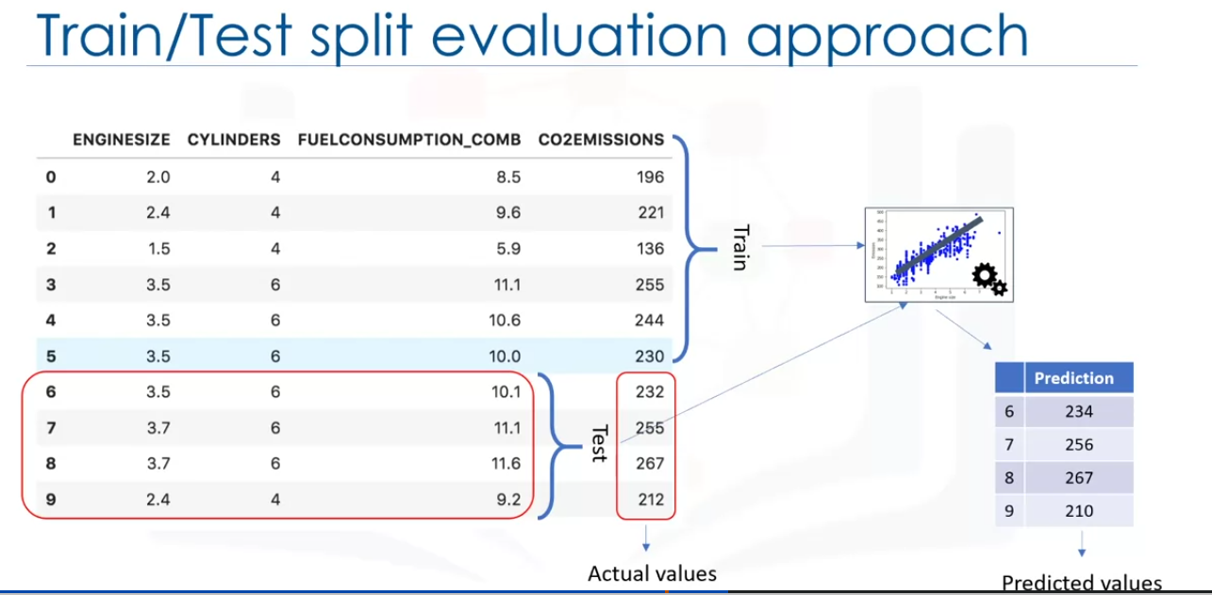

The train test split on the other hand splits the data into taining set and test set which are mutual exclusive. We train the model with only the training data and test it with the test data. This results in higher out of same evaluation. It is highly dependent on the size of the dataset we are using. Once we know that the model has a good accuracy, we train the model with the complete data so that we do not loose any data.

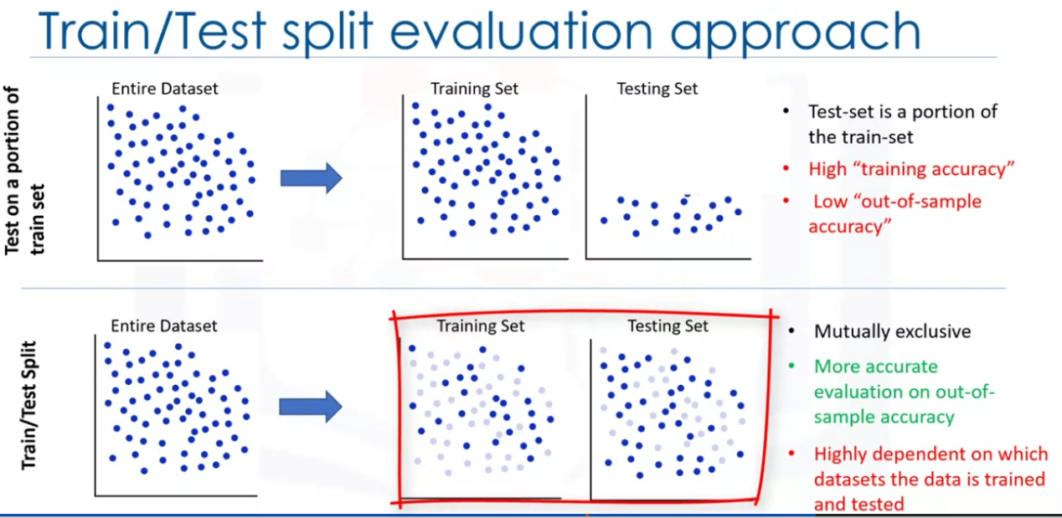

The k-fold cross validation on the other hand splits the data into taining sets and test sets(There will be multiple training sets and multiple test sets from the actual data). Now we train the model with each set and calculate the errors and then perform a mean on them. This is better as every portion of the data becomes test set at some point of the time. This results in high out of same evaluation. The error can be calculated by calculating the mean errors 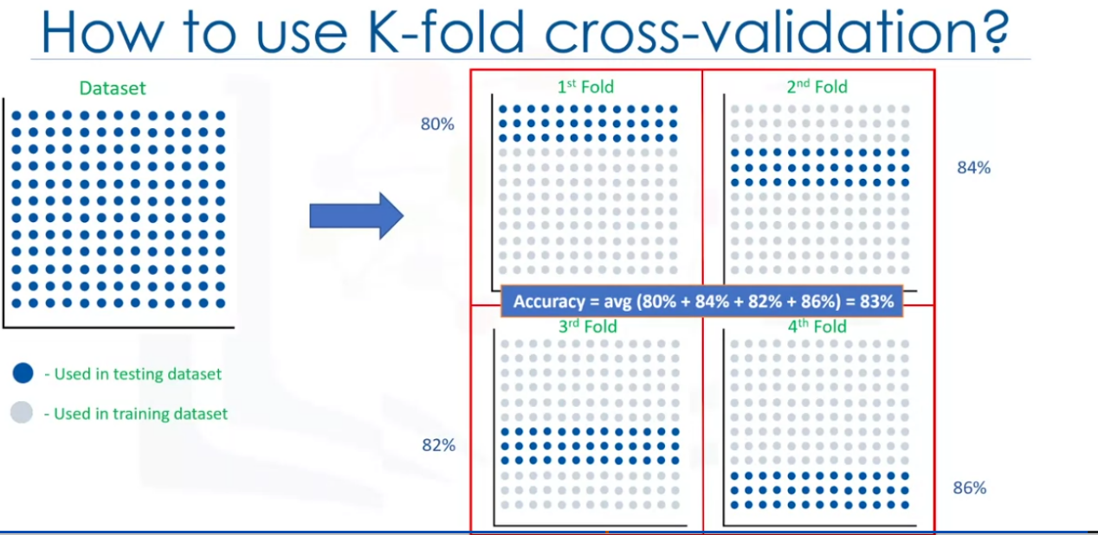

Evaluation Metrics

Used to tell us the performance of the model. Comparing actual value vs predicted values

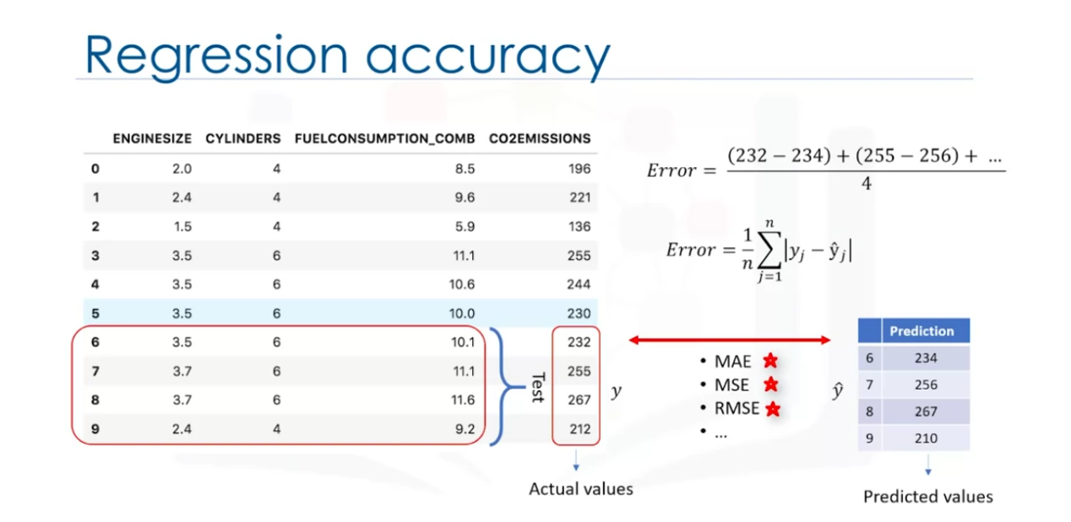

Tese are some of the metrics available.

MAE - Mean Absolute Error

MSE - Mean Squares Error

RMSE - Root mean squared error.

What is an error:

The measure that tells us how far away the actual data point is from the trend line generated by the model.

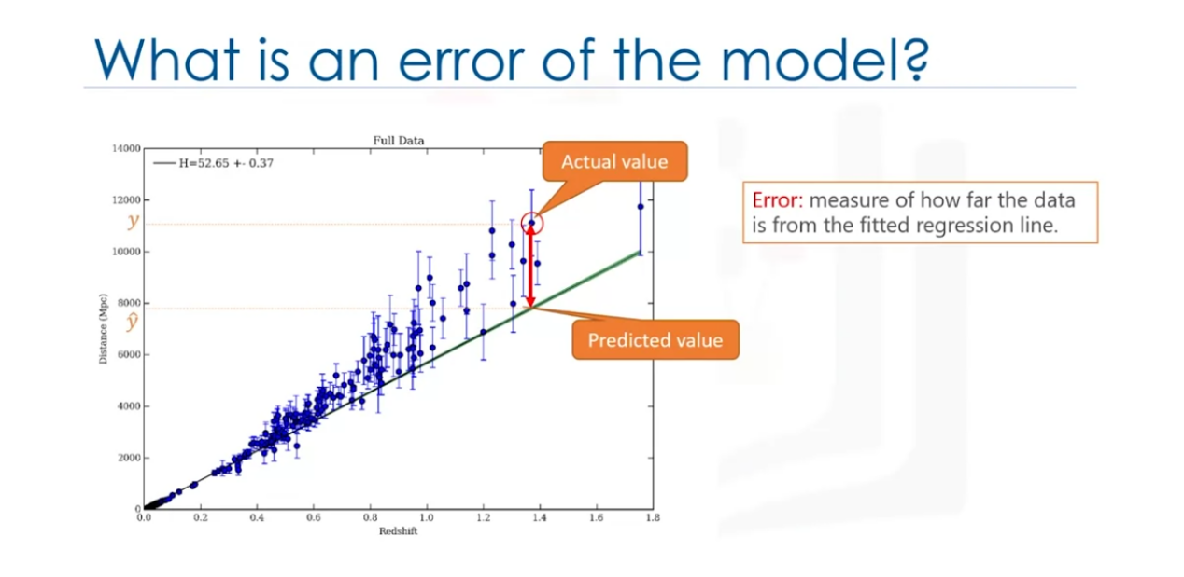

MAE - Its simply the average of all the errors.

MSE- its mean of squared errors - most populat as the focus is geared towards larger errors as each error squares of each larger error becomes way larger compared to smaller error square.

RMSE - It is the root of MSE. most popular as it is interpretable in the same units as the respponse vector or Y units making it easy to relate its information.

RAE - Relative absolute error where Yhat is a mean value of Y. takes the total absolute error and normalizes it. By dividing by the total absolute error of simple predictor.

RSE- Relative squared error is similar to relative absolute error. but it has squares. It is widely used at it is used to calculate r-squared error.

1. squared - R-squared is not an error but its popular metric for the accuracy of your model. It shows how close the data values are to the fitted line. But the errors on the other hand show how far away the data points are. The higher the r-squred, better the model fits the data.

Choosing a metric depends on the type of the model, the type of the data we are using and domain of knowledge.

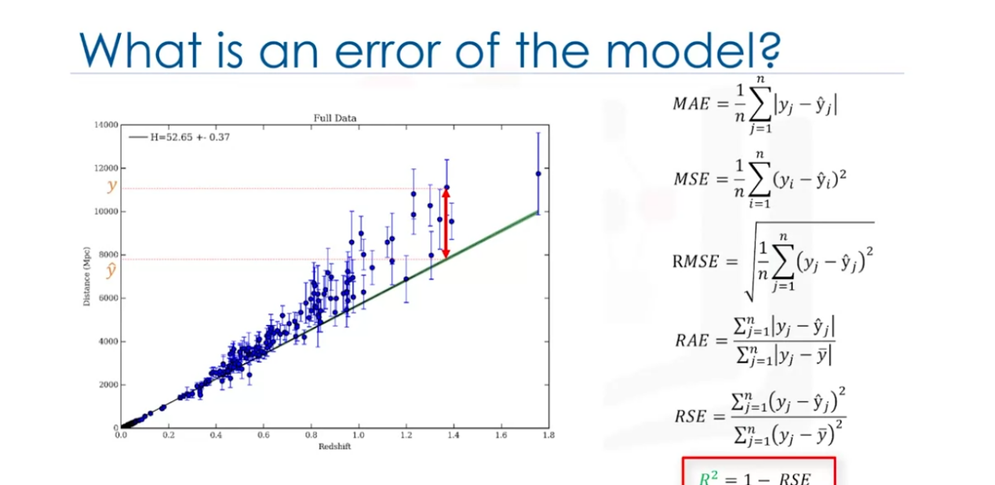

There was an error in the video.

At timestamps 2:01-2:05, an error was made regarding the terminology used. It was stated that "relative absolute error is also known as the residual sum of square."

The fix is:

The correct information is as follows:

Relative Absolute Error (RAE) is a metric expressed as a ratio normalizing the absolute error. It measures the average absolute difference between the actual and predicted values relative to the average absolute difference between the actual values and their mean.

The formula for RAE:

**RAE = Σ|actual - predicted| / Σ|actual - mean|**

It's important to note the distinction between Relative Absolute Error (RAE) and Residual Sum of Squares (RSS):

Relative Absolute Error (RAE): Measures the average absolute difference between actual and predicted values relative to the average absolute difference between actual values and their mean.

Residual Sum of Squares (RSS): Calculates the sum of the squared differences between actual and predicted values.

The formula for RSS:

**RSS = Σ(actual - predicted)^2**

Lab 1

Mutiple Linear Regression

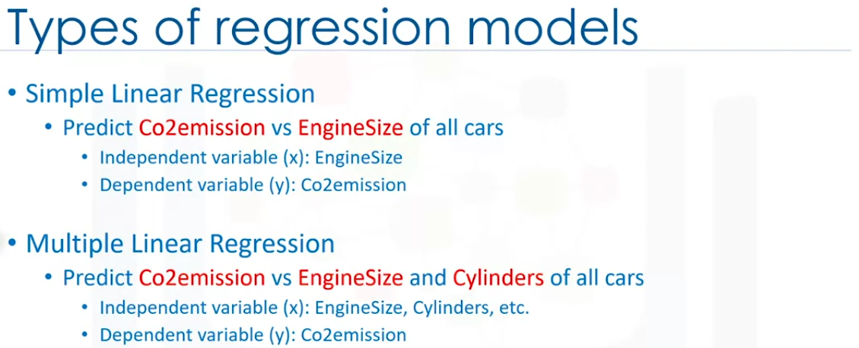

Multiple linear regression uses multiple features instead of single feature.

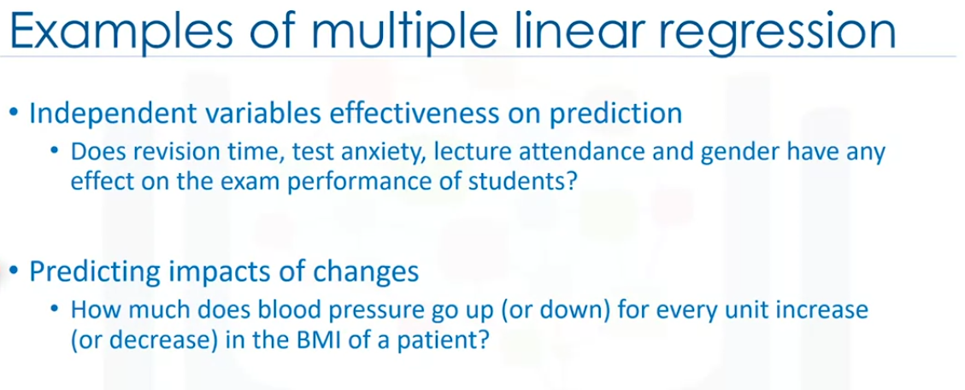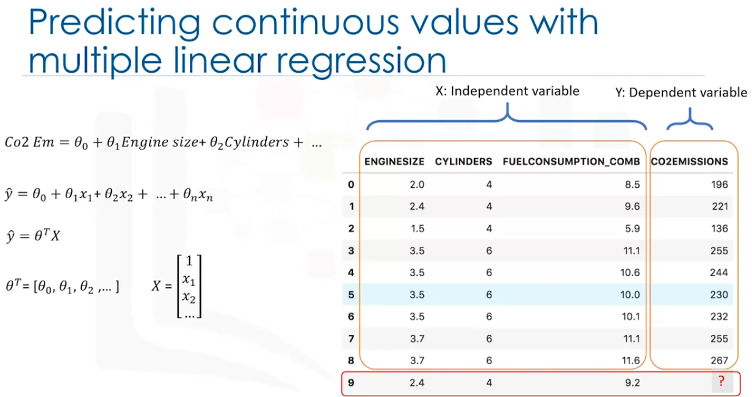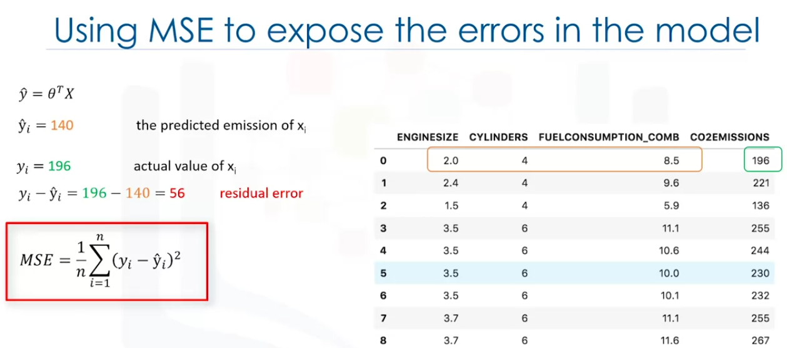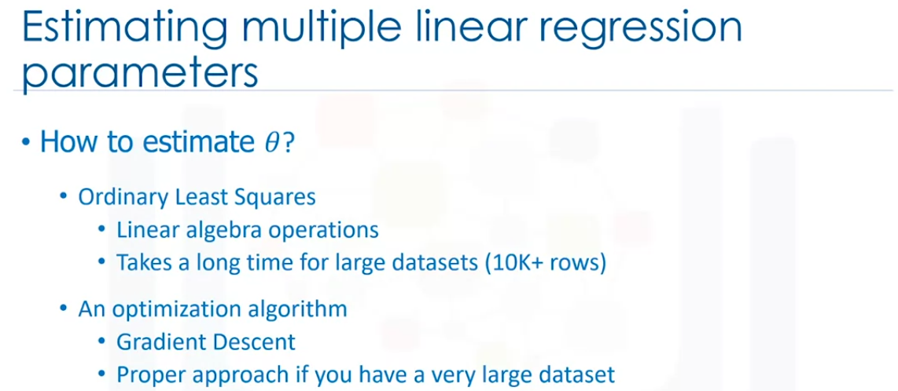

Linear algebra opeartion are matrix operations that runs to calculate coefficients which are slow.

Gradient decent is where it starts with a random values for the coefficients then calculates error and tries to minimize it by multiple iterations.

There are other approaches

then we can use the coeffcients in the formula to find the prediction.

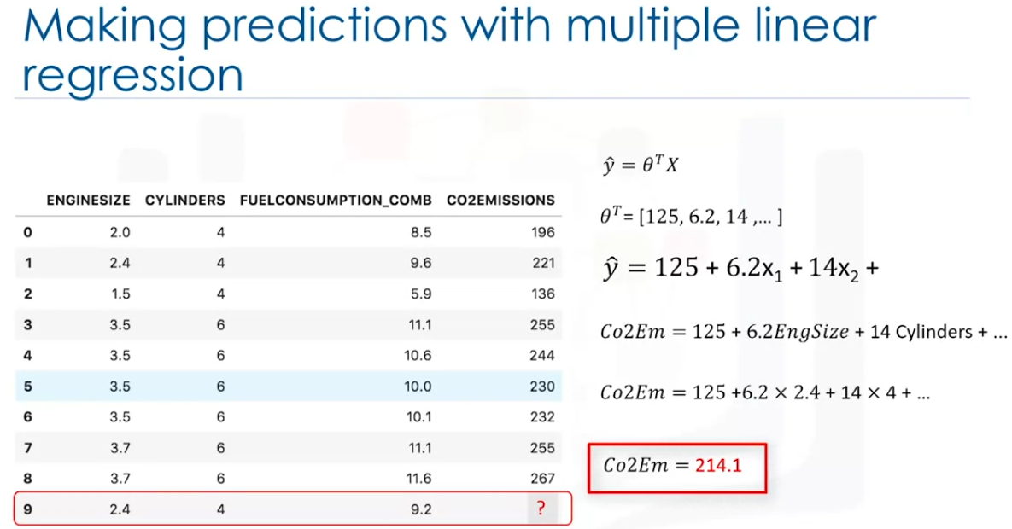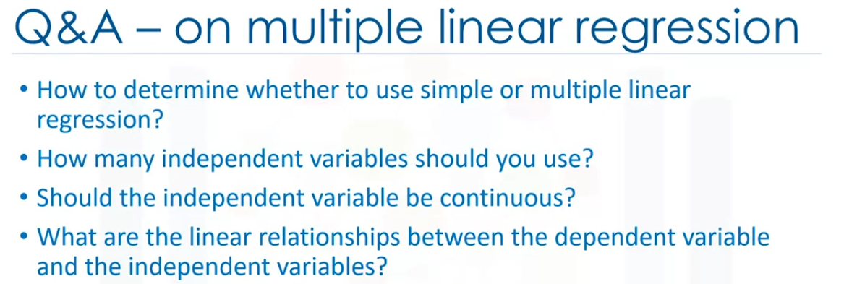

if we multiple variables its better to use multiple linear regression.

if we have to many variables without theoretical justification may result in an overfit model. Avoid doing this.

independent variables can be categorical but has to be converted to numerical variables.

Use scatter plot and check if it is linear.

Errata: Multiple Linear Regression Video

In the prior video "Multiple Linear Regression", an error occurred at the timestamp 10:00 in calculating Theta T, **Predicting with Multiple Linear Regression**. Please see correction below.

The accurate value of Theta T should be as follows:

**Theta T value: [62.43, 9.19, 8.70, 9.68]**

The corresponding regression equation is:

**y_bar = 62.43 + 9.19 * x1 + 8.70 * x2 + 9.68 * x3**

Additionally, at the timestamp 10:20,

the correct predicted CO2 emissions (Co2Em) calculation is:

**Co2Em = 62.43 + 9.19 * 2.4 + 8.70 * 4 + 9.68 * 9.2**

**Co2Em = 208.34**